Measures: Time

6. Time 1

This unit builds on children’s understanding of time, with activities and example questions showing them how to read and use calendars, remember and compare days of the week, and work with the duration of events.

Unit Information

Learning  Outcome(s) | Through appropriately playful and engaging learning experiences, children should be able to understand how time is measured, expressed and represented and explore equivalent expressions of time.
Mathematical Concept(s) | - Time is measured using universal units: seconds, minutes, hours, days, weeks, months, years, etc. There are distinct relations between these units.  - Units of time measure how long something lasts.  - The hour and minute hands of the analogue clock move clockwise as time passes. The two (sometimes three) hands move at different speeds, according to the units of time they are showing.  - Time can be represented in both analogue and digital formats.  - Weeks are measured in multiples of seven days.
Mathematical Language | before, after, earlier, later, o’clock, quarter past, quarter to, half (past), timetable
Prior  Knowledge | - Days of the week, months of the year, and the correct order for each.  - Time can be measured and described using intervals (hours, days, etc.) or qualitative descriptions (today, next week, this Friday, etc.).  - Calendars can be used to plan and record events; they are read from left to right, top to bottom, and each column represents a day of the week.  - Time can be displayed on both analogue and digital clocks (though they may not have used this wording themselves).
Potential  Misconceptions | - The long hand on a clock is the hour hand, as it’s bigger, and the shorter hand is the minute hand. [The opposite is true.]  - Clock hands always point directly at a number. [They’re moving constantly and so the hour hand is pointing between numbers at all times except on the hour, each hour.]

Unit Overview

 | Lesson 1 | Lesson 2 | Lesson 3 | Lesson 4 | Lesson 5
Focus of New Learning | Read the day, date and month using a calendar and answer related questions. | Read and record time in one-hour intervals on analogue and digital clocks. | Read and record time in half-hour intervals on analogue and digital clocks. | Understand simple timetables and answer related questions. | Consolidate Learning.
Slides | 6.1 | 6.2 | 6.3 | 6.4
Book | p. 36 | p. 37 | p. 38 | p. 39 | pp. 40–41
Concrete  Resources |  | analogue and digital clocks  whiteboards | analogue and digital clocks  whiteboards |  | analogue and digital clocks
Digital Resources | 6. Time 1: Game  Planet Maths: Calendar Questions  Planet Maths: Change the Clock  Maths Eyes: Halloween Party
Lesson 1: Read the day, date and month using a calendar and answer related questions.
Teaching Slides 6.1 | Student Book p. 36

Learning Experiences and Anticipated Student Responses

Introduction:
- Use the start of this unit as an opportunity to recap what the children should already know about the different units of time.
- Work through the on-screen statements with the class, and discuss whether they’re always, sometimes or never true. Ask for examples to back up the children’s arguments, or provide counter-examples if they come to the wrong answer themselves (e.g. leap years have 366 days).
- Then move on to the example calendar which, again, should just be a recap as children will have experience with these in previous studies and/or day-to-day life.

Part A:
- Encourage children to keep their symbols simple, to avoid this becoming a drawing task rather than a calendar task.
- Some children may notice that there’s at least one clash; this can prompt a discussion about whether that shows an error (it doesn’t).
- There may also be some debate as to where the trips should also cover the following day (‘48 hour’ and ‘3 day’ are ambiguous as to whether there’s a stay over on the final night, which would extend the trips by a day on the calendar). There’s no right or wrong here, so encourage healthy discussion.
Anticipated Student Responses
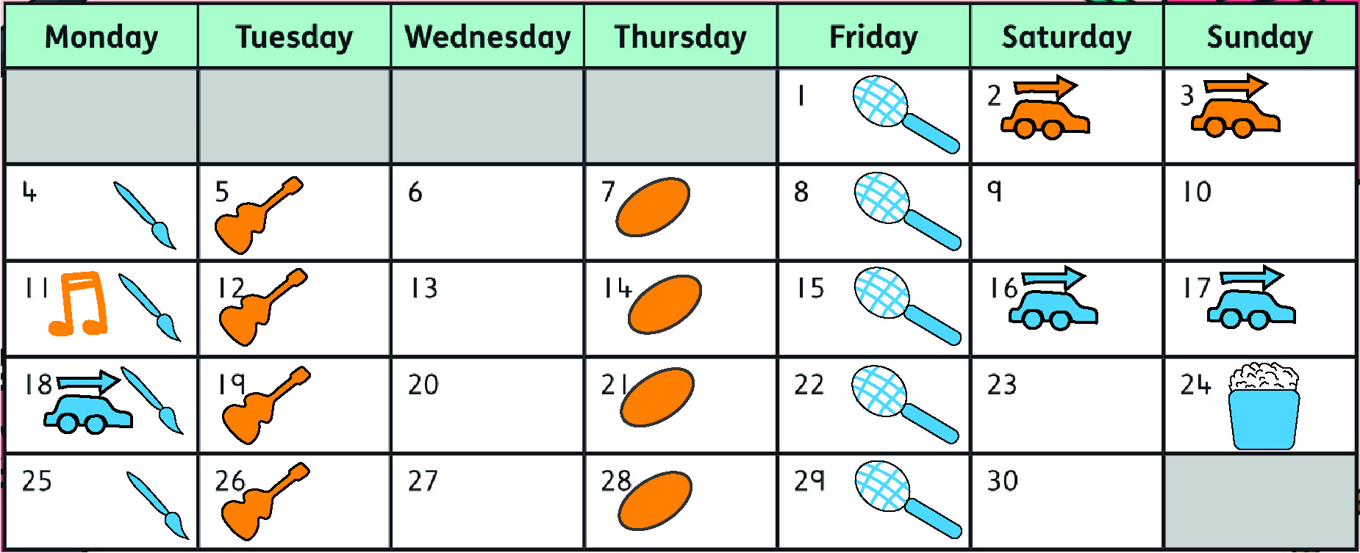

Part B:
- This part should follow on fairly naturally from any discussion held during Part A.
- You may want to show a completed calendar on the screen, to ensure all children can see the same and correct version.
Anticipated Student Responses
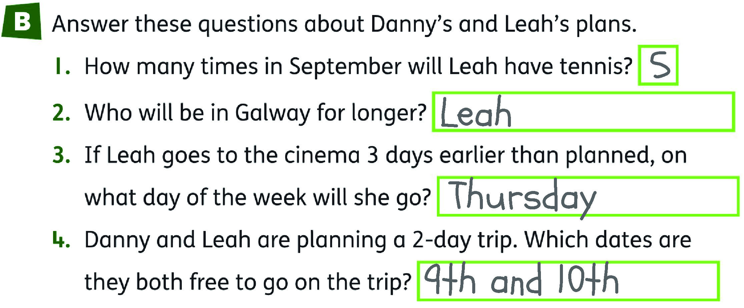

Extension Activity:
- Extension questions about the dates that fall either side of September will help children to think more deeply about the calendar they’ve been given, and how the months tie in together.

Lesson 2: Read and record the time in one-hour intervals on analogue and digital clocks.
Teaching Slides 6.2 | Student Book p. 37 | analogue and digital clocks

Learning Experiences and Anticipated Student Responses

Introduction to clocks:
- Children will of course be familiar with clocks, but this is the first time that analogue and digital clocks have been formally presented together in this course. Spend some time introducing them to the two, and prompting a discussion about where they have seen each type of clock in their daily lives.
- They may need some reminding about which hand is which on an analogue clock, as intuitively the longer hand feels like it should represent the larger time unit, when in fact the opposite is true.

Part A:
Anticipated Student Responses
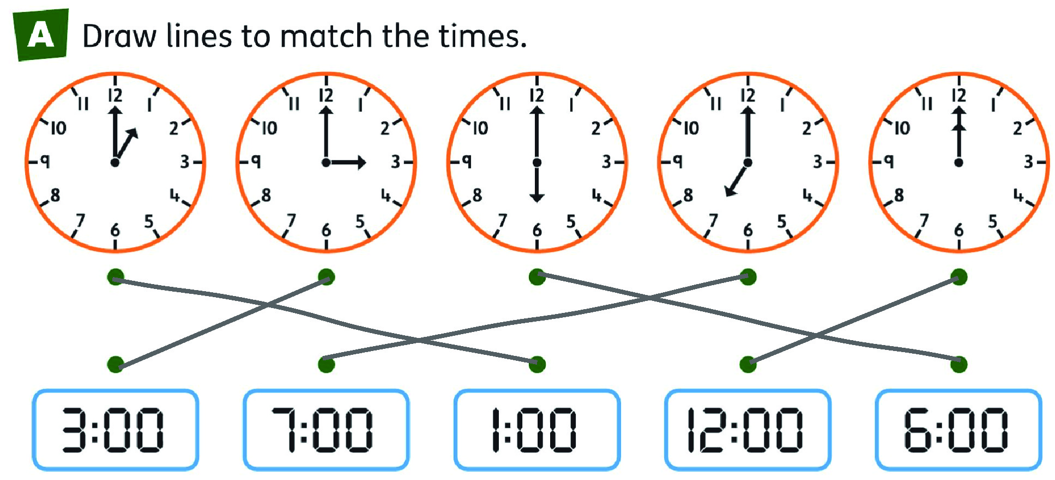

Drawing the time:
Before you move on to Part B, show children the example in which some analogue clocks have been drawn wrong. As usual, encourage discussion around why they’re wrong and how they should be fixed.

Part B:
- As this lesson only looks at ‘on the hour’ times, the long hand will always point to 12; this fact can be shared as a hint for children who are struggling.
Anticipated Student Responses
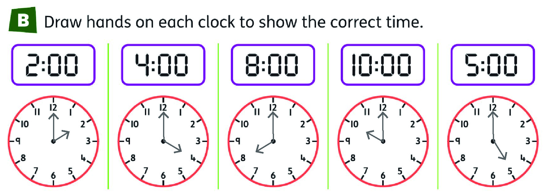

Part C:
- The final part of this lesson gives a nice opportunity to consolidate the children’s knowledge about presenting time in different forms: Digital display, analogue display, and written language.
Anticipated Student Responses
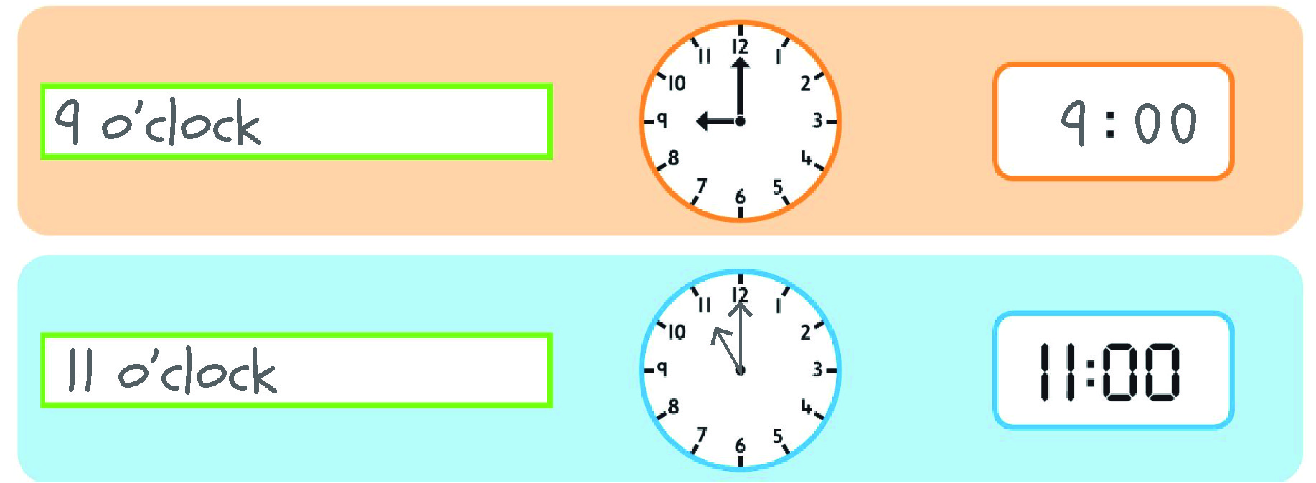

Extension Activity:
- This will challenge children, as first they find the different time as required, then write them digitally.
Of course, 14:00 is a correct response in 24-hour clocks! But as this has not been covered yet, encourage the understanding that after 12 comes 1, so this should be written as 2:00.
Lesson 3: Read and record time in half-hour intervals on analogue and digital clocks.
Teaching Slides 6.3 | Student Book p. 38 | analogue and digital clocks

Learning Experiences and Anticipated Student Responses

Introduction to half past:
- This lesson is virtually the same as the previous lesson, but this time we’re looking at times that are half past the hour, rather than on the hour. The parts in the Student Book are structured in the same way, so any conversations you had in the previous lesson can be repeated for this one.
- The teaching slides begin with various example looking at half-past times on both analogue and digital clocks. Spend time exploring these with the children, drawing their attention towards “What’s the same? What’s different?” between half-past and on-the-hour times, as well as between two or more different half-past times.

Part A:
Anticipated Student Responses
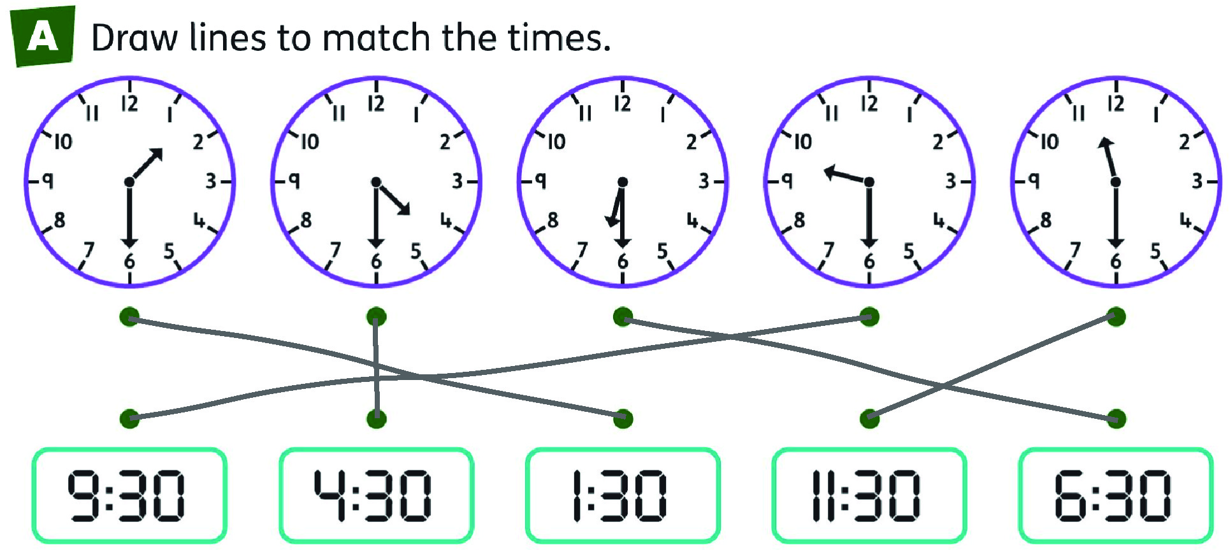

Part B:
- If children are struggling, draw their attention back to what changes and what’s different for each example – i.e. the long hand always points at 6, and the short hand moves around but always points halfway between two numbers.
- Maths Talk: “The hour hand always points down/always points at the 6.”
Anticipated Student Responses
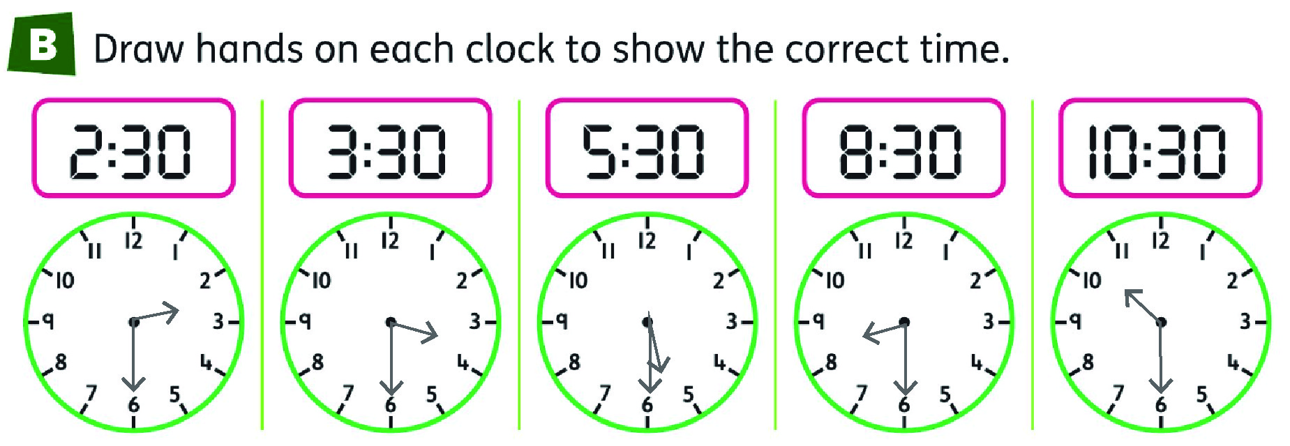

Part C:
- As with the previous lesson, the final part of this lesson gives a nice opportunity to consolidate the children’s knowledge about presenting time in different forms: digital display, analogue display and written language.
Anticipated Student Responses
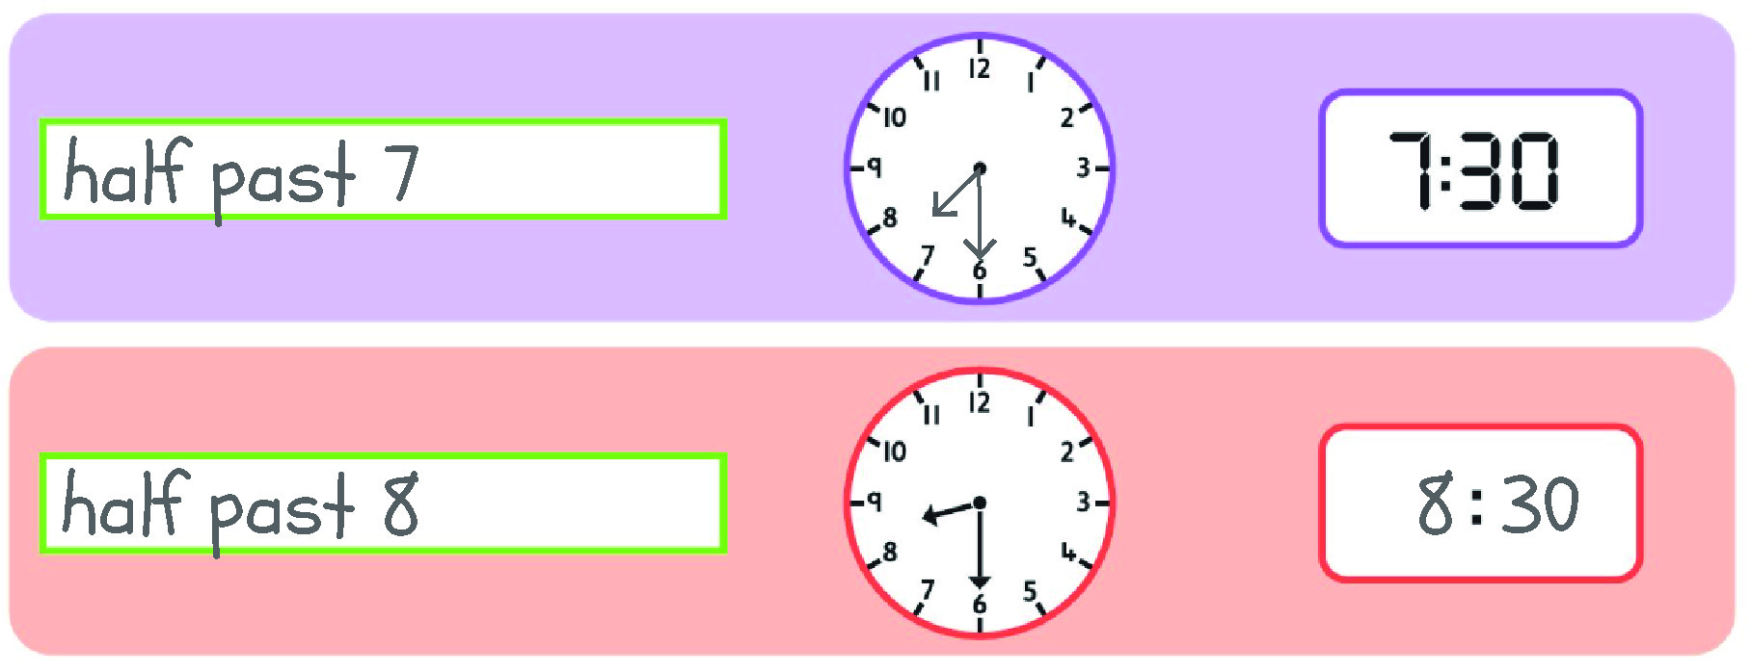

Extension Activity:
- Encourage children to work through the information bit-by-bit to see what it tells them – i.e. minute hand pointing at 6 means it’s half past; hour hand between 12 and 4 means it’s later than 12 o’clock but earlier than 4 o’clock.
Lesson 4: Understand simple timetables and answer related questions.
Teaching Slides 6.4 | Student Book p. 39

Learning Experiences and Anticipated Student Responses

Introduction to timetables:
- The teacher slides contain an interactive timetable that lets you introduce the elements of one bit-by-bit. Discuss these with the class and encourage discussion on how we can use timetables in everyday life.
- Maths Talk: “A timetable tells us when we can/need to do something.”
- Maths Talk: “It tells us how long swimming lessons last.” “I know when fun swim time starts and ends.”

Part A:
- There should only be one correct answer for each question, though there may be confusion as to how long ‘home time’ lasts; in this example, it’s a one-off event that denotes the end of the day, but in the previous swimming example, the final item on the calendar was the start of the final session. This can prompt a class discussion on how some elements can be open to interpretation.
- Maths Talk: “Some activities last half an hour but some activities last 1 hour.” “There are 3 activities before lunch and 2 activities after lunch.”
Anticipated Student Responses
- 9 o’clock / 9:00
- 2 o’clock / 2:00
- Music
- Lunch
- Half an hour / 30 minutes
- Basketball
- Art
- 5 hours

Part B:
- There is a problem-solving element to this part, such that children may need to be walked through it to a certain extent.
- There are also different possible combinations, which can prompt interesting class discussion. Use a few different examples, work through the rules to check they’re all followed, and then compare and contrast.
Anticipated Student Responses
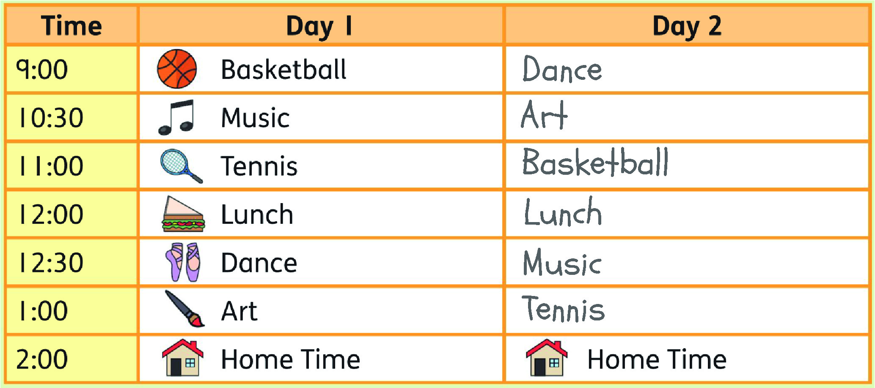

Extension:
- Children are encouraged to create their own timetable. Remind them that they’re not bound to the same activities as those given in the Student Book; they can be as creative as they like.

Lesson 5: Consolidate learning.
Student Book pp. 40–41 | analogue and digital clocks

Learning Experiences and Anticipated Student Responses

Part A, p. 40:
Anticipated Student Responses
- There are 4 seasons in a year.
- There are 3 months in each season.
- There are 2 weeks in a fortnight.
- There are 12 months in a year.
- There are 365 days in a regular year.
- There are 366 days in a leap year.
- There are 10 years in a decade.

Part B, p.40:
Anticipated Student Responses
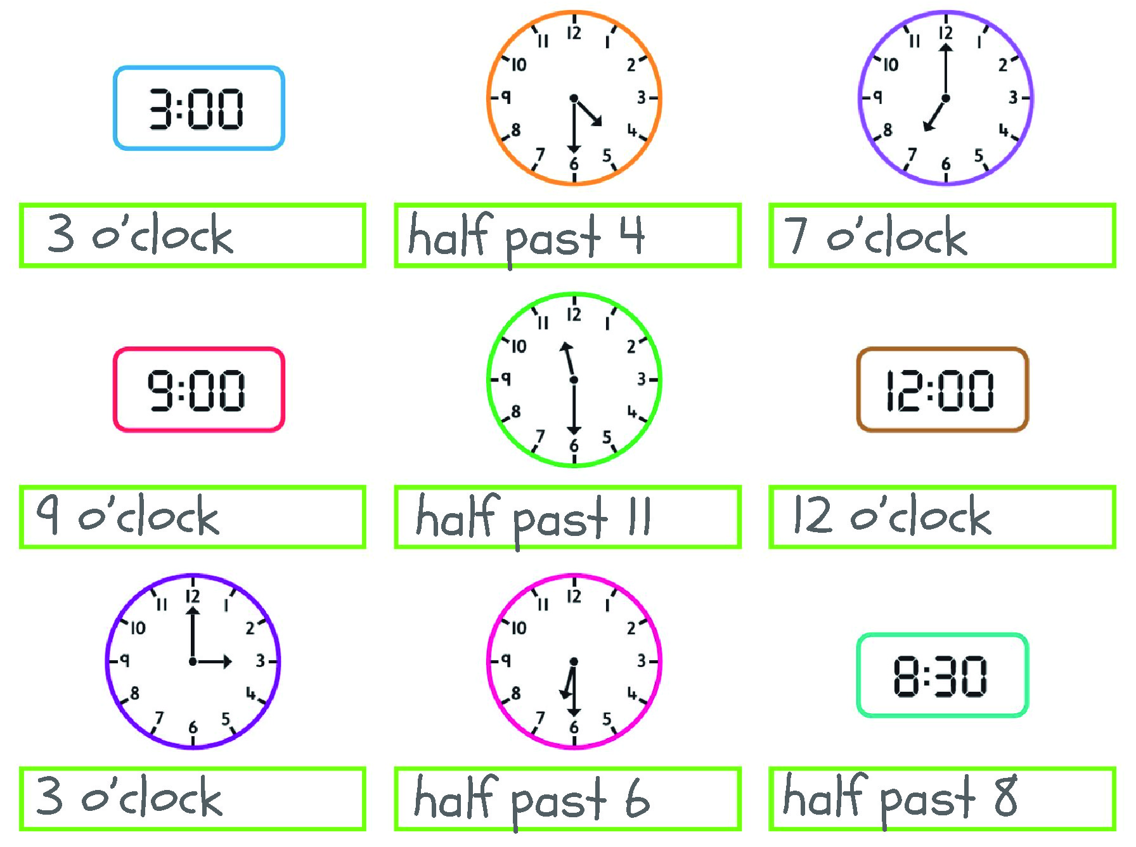

Part A, p. 41:
Anticipated Student Responses
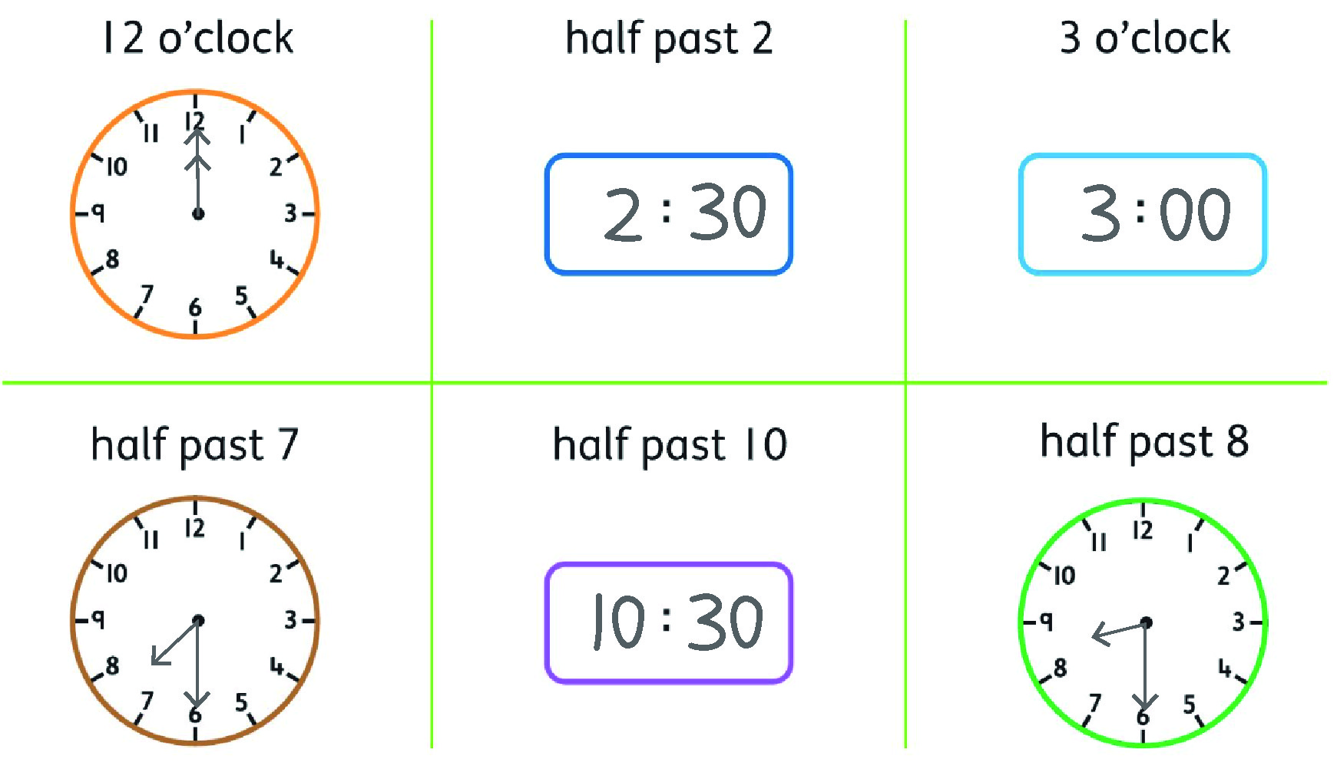

Part B, p. 41:
Anticipated Student Responses
- 9:00 / 9 o’clock
- 2:30 / half past 2
- Irish
- 1 hour
- Art
- Any two from: English, Maths, Irish and Break

