Shape and Space: Transformation

26. Transformation

This unit explores 2D shapes and their transformational properties, through a mix of interactive activities and hands-on problems.

Unit Information

Learning  Outcome(s) | Through appropriately playful and engaging learning experiences, children should be able to model and explain the effects of transformations on shapes and line segments.
Mathematical Concept(s) | - A shape or pattern has rotational symmetry if it looks the same after a rotation of less than one full turn.  - Tessellation involves covering a surface with no gaps or overlaps, using one or more geometric shapes. Certain shapes and combinations of shapes can tessellate.  - Regular tessellations are tessellations of regular polygons. There are three types of regular tessellations: triangles, squares and hexagons.
Mathematical Language | shape, 2D shape, transformation, rotation (turn), reflection (flip), translation (slide), side, vertex, vertices, angle, symmetry, tessellate, tessellating pattern, horizontal line of symmetry, vertical line of symmetry, rotational symmetry, regular shape, irregular shape
Prior  Knowledge | - Different shapes can have the same or different properties.  - Shapes can be sorted into given families or categories based on their properties.  - Tessellating shapes are shapes that can be put together in a pattern with no gaps.  - Shapes can be rotated, reflected or translated to form a new shape and/or the same shape in a new position.  - Some shapes have rotational symmetry.
Potential  Misconceptions | - When a shape is transformed (rotated, reflected, translated), its properties change. [A shape’s properties never change due to a transformation.]  - If a shape has a vertical line of symmetry, it must have a horizontal line of symmetry too. [A shape that is symmetrical one way does not necessarily mean it is symmetrical the other way too.]  - All regular shapes tessellate. [Not all regular shapes tessellate.]  - Irregular shapes do not tessellate. [Some irregular shapes do tessellate.]

Unit Overview

 | Lesson 1 | Lesson 2 | Lesson 3 | Lesson 4 | Lesson 5
Focus of New Learning | Explore transformations of shapes and investigate if their properties will change. | Explore line and rotational symmetry and describe features of both. | Make tessellating patterns involving the transformation of shapes. | Explore and describe regular tessellation. | Consolidate learning.
Slides | 26.1 | 26.2 | 26.3 | 26.4
Book | p. 156 | p. 157 | p. 158 | p. 159 | pp. 160–161
Concrete  Resources | Printable 26.1 & 26.2  2D shapes  mirror | Printable 26.3 & 26.4  mirror | pattern blocks | 2D shapes
Digital Resources | 26. Transformation: Game  26. Transformation: Video

Lesson 1: Explore transformations of shapes and investigate if their properties will change.
Teaching Slides 26.1 | Student Book p. 156 | Printable 26.1 & 26.2, 2D shapes, mirror

Learning Experiences and Anticipated Student Responses

Bolt’s ‘person beside a tree’ and introduction to rotate/reflect/translate
- Children should be familiar with the concept of transformations, but it may be the first time they are encountering them in quite a while. Spend some time working through the transformations of Bolt’s drawing and discussing Wind, Brain and Blaze’s statements.
- Maths Talk: “Wind is correct. The person can turn left or right and they can part or whole turns.”
- Maths Talk: “Brain is correct. The person can be reflected vertically or horizontally.”
- Maths Talk: “There are lots of ways to translate the person! They can move any distance/direction.”
- Discuss how to spot changes that indicate a shape has been rotated, reflected or translated.
- Maths Talk: “When a shape rotates, it turns left/right.”; “When a shape is reflected, it is flipped.”; “When a shape is translated, it moves to a new location but doesn’t turn.”

Part A:
- Having practised transforming shapes in the lesson introduction, this activity should be okay for most children. E and F are the most challenging transformations to identify.
- Draw focus to the person’s arms and legs, and discuss what reflections and might look like if the person had been symmetrical.
Anticipated Student Responses
- A, F 2. C, E 3. B, D

Part B:
- Children’s answers will vary. They may need a reminder of the meaning of the word ‘tessellate’ as it may be a while since they have heard of or used the term. They may also need reminding that the word ‘vertices’ is another word for ‘corners’, and it is the plural or ‘vertex’.
Anticipated Student Responses
- The triangle has 3 sides / 3 vertices / 3 angles / 3 lines of symmetry and it will tesselate.
- The square has 4 sides / 4 vertices / 4 (right) angles / 4 lines of symmetry and it will tesselate.
- The hexagon has 6 sides / 6 vertices / 6 angles / 6 lines of symmetry and it will tesselate.

Part C:
- These statements are designed to get children thinking about the relationship between properties and transformation, guiding them to the understanding that properties do not change transformation.
Anticipated Student Responses
- never true
- always true
- always true
- Maths Talk: “When a shape is transformed, its properties do not change.”

Extension:
- Encourage children to use square paper to guide them and a mirror to check the reflection of their stick person. It may be useful for children to draw a line down the middle of their page and then draw one half of their stick person on one side and mirror that half on the other side of the line.
- As an additional fun challenge, discuss whether it’s possible to draw a stick person that looks the same if reflected vertically.
Anticipated Student Responses
Children’s stick people will vary but should look the same when reflected.
Focus on vertical reflection for this exercise.
Lesson 2: Explore line and rotational symmetry and describe features of both.
Teaching Slides 26.2 | Student Book p. 159 | Printable 26.3 & 26.4, mirror

Learning Experiences and Anticipated Student Responses

Shape families:
- Have the children cut out their 2D shapes from Printable 26.3. Encourage them to separate the shapes into their shape families, e.g. 3-sided shapes, 4-sided shapes, etc. This can help them estimate if their shapes will have one, two or more lines of symmetry without folding. It can also show them that some shapes in the same shape family do not have the same number of lines of symmetry.
- Maths Talk: “Does a triangle with 3 equal sides have the same number of lines of symmetry as a triangle with only 2 equal sides? How do you know?”, “Does a square have the same number of lines of symmetry as a rectangle? Why or why not?”

Part A:
- Encourage children to use the 2D shapes they cut out to help them with this activity. They can use a mirror to check. Alternatively, children can fold the shapes in half from different directions and draw along the lines created to make them easier to count.
- The parallelogram can prompt discussion over the fact that parallel or matching sides do not necessarily imply lines of symmetry (it intuitively feels like a parallelogram should have lines of symmetry).
Anticipated Student Responses
- 4 | - 2 | - 6
- 3 | - 1 | - 0

Part B:
- Like in Part A, children can use a mirror to check which letters are symmetrical and which are not. Encourage them to look closely to see that, while some letters may look symmetrical, they are not, such as B and K.
- It’s worth noting that certain letters, like B, Y or K, can be written in different ways such that they sometimes do and sometimes do not have lines of symmetry.
- This question asks children to find ‘some’ examples so that it is low-threshold high-ceiling, and some children will find more examples than others.
Anticipated Student Responses
- (B), C, D, E, H, I, O, X
- A, H, I, M, O, T, U, V, W, X, Y
- H, I, O, X
- (B), F, G, J, K, L, N, P, Q, R, S, Z

Part C:
- Upon first encounter, it may be more challenging for children to gauge which letters qualify for rotational symmetry. Encourage them to draw the letter H on a piece of paper and rotate it 180 degrees. Ask them what they notice; they should see that it is the same when turned like this. Use S as the next example if they are still not sure.
- Again, this question asks children to find ‘some’ examples. Some children may find more examples than others.
Anticipated Student Responses
- H, I, N, O, S, X, Z
- A, B, C, D, E, F, G, J, K, L, M, P, Q, R, T, U, V, W, Y

Extension:
- Encourage children to use their methods and answers from Parts A and B to work out this question.

Lesson 3: Make tessellating patterns involving the transformation of shapes.
Teaching Slides 26.3 | Student Book p. 160 | pattern blocks

Learning Experiences Anticipated and Student Responses

Tessellating patterns:
- Provide children with a mix of illustrated and real-life examples of tessellating patterns, and ask them to find the shape in each that is creating the pattern. Provide some visual examples of patterns that do not show tessellations to check whether children understand the difference.
- Encourage children to look around the classroom, school or yard (where suitable) to see if they can find any tessellating patterns in real life.
- Maths Talk: “No this does not show tessellation, because all the shapes are different (sizes).” / “Yes this shows tessellation, as the same shapes are repeating.”

Part A:
- If possible, the use of Polypad to illustrate these patterns, rather than physical blocks, is highly recommended for this activity.
Anticipated Student Responses
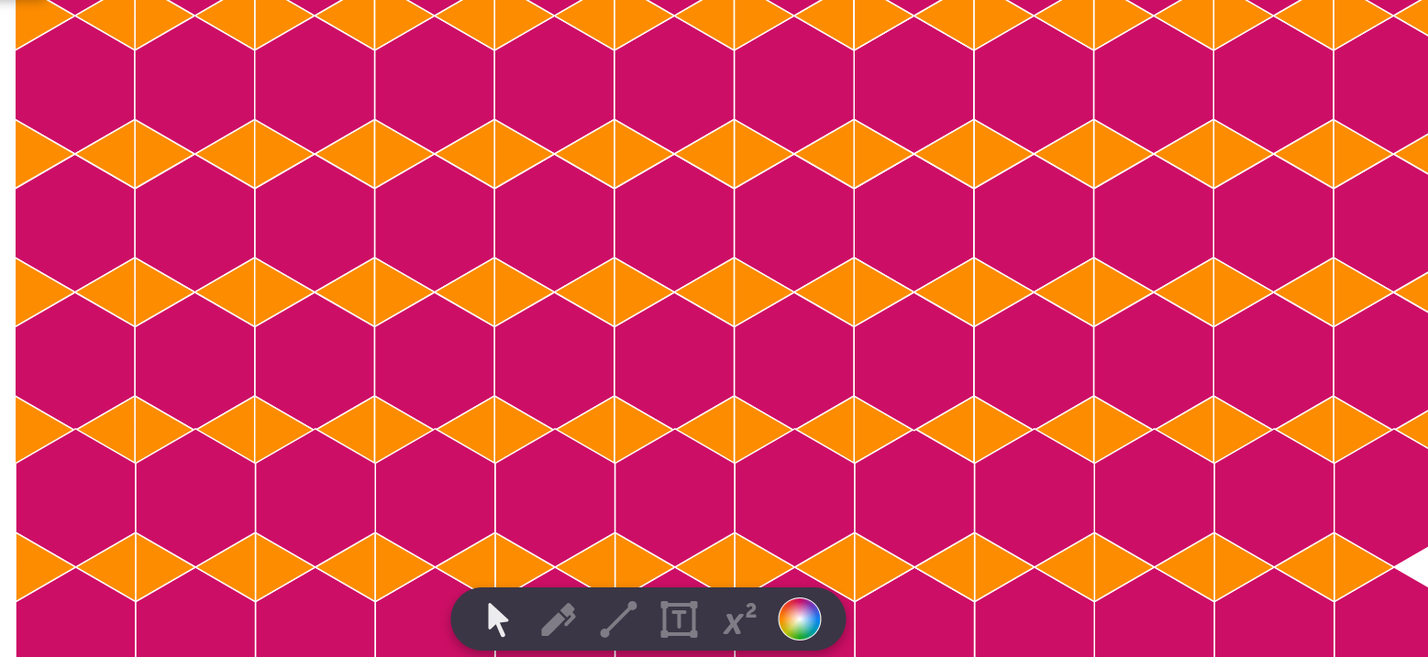  1. | 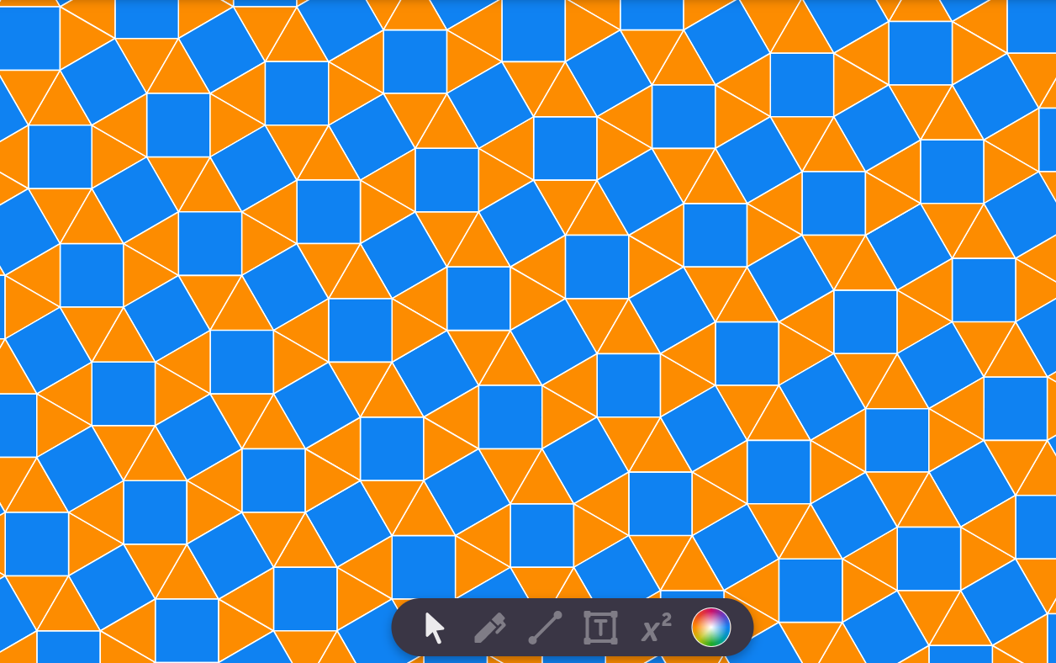  2. | 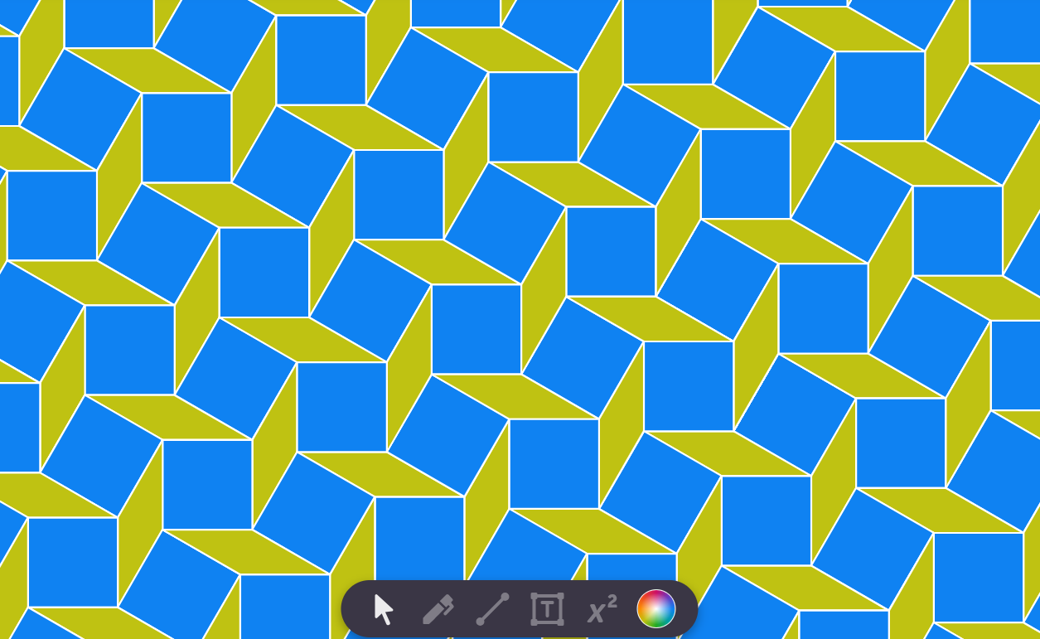  3.
- Maths Talk: “Yes it does! The same shapes are translated lots of times / the shape are rotated and reflected into lots of different positions.”

Part B:

Anticipated Student Responses
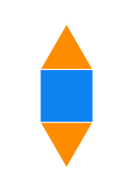 | 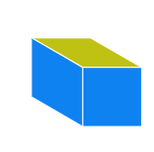

Part C:
- There are many possible patterns that children can make using the assortment of shapes provided. Check and make sure their patterns are tessellating, and advise what can be changed if they are not.

Extension:
- This is an extension of Part C, and there are many possible patterns for the children to make. Check and make sure the patterns children provide to their partner can tessellate, and advise them to work together to find out what can be changed if they cannot. Check that there are no gaps in the pattern.
Lesson 4: Explore and describe regular tessellation.
Teaching Slides 26.4 | Student Book p. 161 | regular shapes

Learning Experiences and Anticipated Student Responses

Regular shapes:
- Start off this lesson by reminding children what the meaning of a regular shape is and how to spot them. Provide examples of regular shapes and irregular shapes to illustrate the difference.
- Maths Talk: “I agree with Pulse! The rectangle is not regular because not all its sides are the same.”
- Some regular shapes do not tessellate, while some irregular shapes do. Illustrate this so that children do not come to the assumption that ‘regular’ means ‘tessellating’ and ‘irregular’ means ‘not tessellating’.

Part A:
- If possible, the use of Polypad to illustrate these patterns, rather than physical blocks, is highly recommended for this activity.
- As children sketch out tessellations, check and make sure they are drawing the shapes correctly; changing the angle of the shapes to allow them to fit them together may cause confusion, e.g. rotating the triangle 180 degrees. Only the triangle, square and hexagon can tessellate in this activity.
- If any children try to force a shape that does not tessellate to do so by distorting it (pentagon/octagon), encourage them to stop and assess whether they have drawn their shape with sides that are all the same length and angles that are all the same size.
Anticipated Student Responses
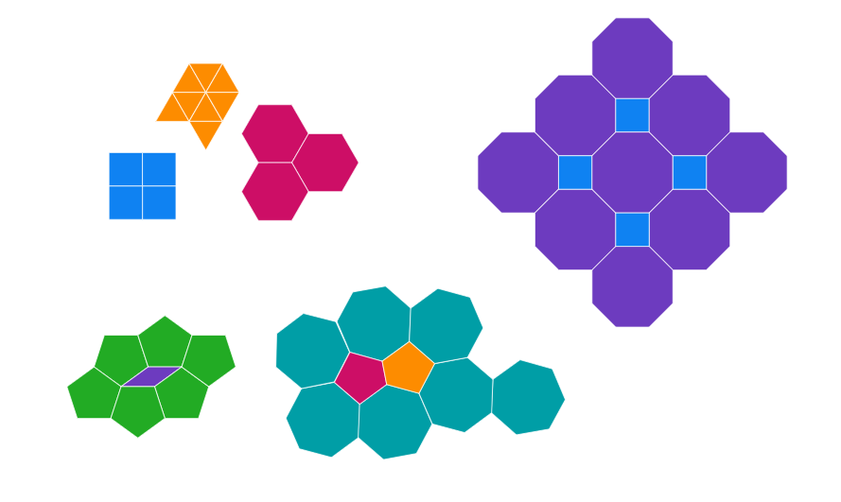
Brain’s statement is sometimes true.
Children can show this by finding examples that do tessellate:
regular triangles, squares and hexagons
and examples that do not tessellate:
e.g. regular pentagons and octagons.

Part B and preceding activity:
- Having just tried to use shapes to make tessellating patterns, children will now need to look at tessellating patterns and work out what shapes they can make out. The slide before Part B gives them a gentle entry point, with regular triangles, squares and hexagons.
- For Part B, there are many possible combinations of the tessellating regular shapes provided in Part A that children use to make a pattern that will cover a surface. Check and make sure their patterns are tessellating and advise what can be changed if they are not.

Part C:
- This activity recalls the knowledge learned in Lesson 1 of this unit. Children should still be familiar with rotations, reflections and translations, but a recap of the terms and their transformations before this activity may be beneficial.
Anticipated Student Responses
- rotation
- (vertical) reflection
- (horizontal) reflection (or vertical reflection and rotation)
- translation

Extension:
- If possible, use Polypad to illustrate examples of irregular shapes that do tessellate. They should see from Part C that the tetrominoes are irregular shapes that can tessellate. Other shapes to use as examples include rectangles, right-angled triangles and parallelograms. Encourage children to draw an irregular shape that will tessellate to make a pattern in their copybooks.
Lesson 5: Consolidate learning.
Student Book pp. 162–163

Learning Experiences and Anticipated Student Responses

Part A, p. 162:
Anticipated Student Responses
  1. |   2. |   3.

Part B, p. 162:
Anticipated Student Responses
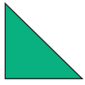  1. | 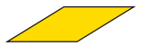  2. | 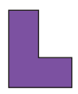  3.

Part C, p. 162:
Anticipated Student Responses
- reflection
- rotation
- reflection
- rotation

Part A, p. 163:
Anticipated Student Responses
- 2
- 5
- 1
- 1

Part B, p. 163:
Anticipated Student Responses
A and D

Part C, p. 163:
Anticipated Student Responses
A and D

Part D, p. 163:
Anticipated Student Responses
- (vertical) reflection
- (horizontal) reflection (or reflection and rotation)
- translation
- rotation

