Number: Place Value and Base Ten

23. Decimals

This unit explores decimal numbers, with examples and worked activities to help children investigate how they can be represented in different forms, and how they can be rounded to different place values.

Unit Information

Learning  Outcome(s) | Through appropriately playful and engaging learning experiences, children should be able to explore equivalent numerical expressions of numbers using the base ten systems.
Mathematical Concept(s) | - The value of each digit in an integer or decimal number is a multiple of the value of its place.  - The value of an integer or decimal number is a multiple of the value of its place.  - The principle of base ten holds for integers and decimals.  - Notwithstanding the conventional notation, numbers can be represented in different, equivalent ways using concrete materials (e.g., 46 = 4 tens and 6 units or 3 tens and 16 units).  - A decimal point is a convention that separates the integer part of the number (left) from the fraction part of the number (right).  - The base ten place value system extends indefinitely in two directions multiplying (to the left) or dividing (to the right) by multiples of ten.
Mathematical Language | 100-grid, fraction, decimal, decimal number, place value, digit, part, whole, tenths, hundredths
Prior  Knowledge | - Fractions and decimals are two ways of representing parts of whole numbers.  - Fractions represent parts of whole numbers, such as halves, quarters, tenths and hundredths.  - Cubes can be used to represent parts of numbers.  - Numbers can be compared by looking at the digits in equivalent place values.  - Numbers round down if the relevant place value is less than 5, or up if it’s more than 5.
Potential  Misconceptions | - Fraction denominators and decimal digits are equivalent in value, e.g. ½ is the same as 0.2 or 1.2. [1/2 is the same as 0.5]  - Hundredths are larger than tenths. [the decimal place values decrease in size.]

Unit Overview

 | Lesson 1 | Lesson 2 | Lesson 3 | Lesson 4 | Lesson 5
Focus of New Learning | Make connections between fractional and decimal hundredths. | Express known fractions and decimals, e.g. 25/100 = 0.25 = ¼. | Understand that decimal numbers can be represented in different ways. | Round numbers with one decimal place to the nearest whole number. | Consolidate learning.
Slides | 23.1 | 23.2 | 23.3 | 23.4
Book | p. 138 | p. 139 | p. 140 | p. 141 | pp. 142
Concrete  Resources | place value cards  scissors and paper strips | Printable 23.1 | base ten blocks  place value charts
Digital Resources
Lesson 1: Make connections between fractional and decimal hundredths.
Teaching Slides 23.1 | Student Book p. 138 | place value cards, scissors, paper strips

Learning Experiences and Anticipated Student Responses

Introduction activities and Part A
- Start the children off by using a strip of paper to represent a whole broken into tenths, and use it to represent the different numbers.
- Maths Talk: “We could write them as fractions over 10.”
- Then move on to the comparisons of tenths and hundredths. Ask children to discuss whether Pulse and Bolt are correct (they are).
Anticipated Student Responses
1.  0.04 | 2.  0.32 | 3.  0.95 | 4.  0.55

Part B
- Help children to make their own place value charts before answering Part B.
- Remind them to include the decimal point, and that tenths, hundredths etc. go in the opposite direction to tens, hundreds, etc. (i.e. to the right, not the left).
- They should then use their charts to create all the decimals shown in the student book.

Part C
- Children should recognise that for the largest number, the largest digits should be in the largest place values. And for the smallest number, the opposite is true.
Anticipated Student Responses
- 873
- 3.78
- Possible options are 78.3, 87.3, 7.38 and 8.37

Extension
- Children should recognise by now that 0.06 is less than 0.6. Encourage them to make each number in their place value charts and show that 6 hundredths are less than 6 tenths.

Lesson 2: Express known fractions as decimals, e.g. 25/100 = 0.25 = ¼.
Teaching Slides 23.2 | Student Book p. 139 | Printable 23.1

Learning Experiences and Anticipated Student Responses

Part A and introduction
- Spend some time exploring Pulse’s pattern of squares. This type of activity will reappear later in the lesson, so it’s important to ensure children are comfortable with relating coloured squares to the fraction or decimal they represent.
- Then ask them to complete Pat A, which sets the foundation for the more applied examples to follow.
Anticipated Student Responses
- Each square is 1 out of 100 equal squares.
- 1 square = 0.01 or 1/100.
- 1 row = 0.1 or 1/10.
- 1 column = 0.1 or 1/10.

Bolt, Blaze and Wind’s squares:
- This activity aims to solidify the equivalence between different representations: all three characters are giving valid descriptions for the number of coloured squares.
- Maths Talk: “They are all correct!”

Part B
- For some extra challenge in this question, you can ask children to simplify their fractions. In some cases they are likely to simplify without giving the simplest form, so you can keep encouraging them to consider whether there’s any more they can do. Manipulatives will help them to reason this out.
Anticipated Student Responses
30 squares is equal to 30/100 or 3/10.
40 squares is equal to 40/100 or 2/5.
6 columns is equal to 6/10 or 3/5.
7 rows is equal to 70/100 or 7/10.

Shaded or unshaded:
- This activity helps the children to understand that fractions and decimals can be combined to create other familiar fractions and decimals. They should see that two quarters make a half, and then another quarter again makes three quarters.
- To find the amount of the design that is unshaded, students may just visually compare it to the blue region. You could also encourage them to think about what’s left if three quarters are shaded.
- Maths Talk: “One quarter of it is unshaded.”

Part C
- Show children the picture as is and then the picture with colours grouped together. Reorganising and grouping together the colours makes it much clearer to see how many of each there are.
- Maths Talk: “We can group each of the colours together and see if we can make quarters or halves.”
Anticipated Student Responses
- Blue
- Green
- Yellow
- ¾ or 0.75

Part D and extension:
- Encourage children to think about their spread of colours before they start drawing, or they are likely to find themselves with numbers of squares that don’t make nice fractions (which is the purpose of this lesson; the fallback option of fractions over 100 is available but not ideal).
- Have nicely convertible fractions will also lead more nicely into the extension, where e.g. quarters can be converted into 25ths or hundredths.
Lesson 3: Understand that decimal numbers can be represented in different ways.
Teaching Slides 23.3 | Student Book p. 140 | base ten blocks, place value charts

Learning Experiences and Anticipated Student Responses

Introduction:
- Begin this lesson with the various examples and activities at the start of the teaching slides. Get children used to the idea of 100 small blocks representing one whole, with each block being one hundredth.

Part A:
- Children now put into practice the activities from the start of this lesson.
Anticipated Student Responses
- 1.44
- 3.25
- 2.90
- 0.58

Part B:
- Encourage children to use base ten blocks and place value charts to work through these numbers, and encourage them to come up with different solutions to each category if time. They should see that multiple options are available in most cases.
Anticipated Student Responses
Student responses will vary. E.g.:
6.89
20.51
8.88
0.04

Part C and preceding activities:
- Work through the Blaze and Wind discussion with the class, and encourage the use of base ten blocks and place value charts to determine who’s correct. Children should quickly see that 50 tenths is wrong.
- As in Part B, there are various different solutions that children could write for Part C. Encourage discussion with partners or with the whole class, and compare different solutions.
- Maths Talk: “I can partition in lots of different ways, if I make sure the number of tenths and hundredths stays the same.”
Anticipated Student Responses
Student responses will vary. E.g.:
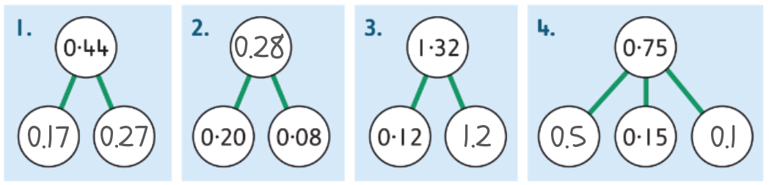

Part D:
Anticipated Student Responses
- 13 hundredths = 1 tenth and 3 hundredths
- 46 hundredths < 45 tenths
- 5 hundredths < 50 tenths

Extension:
Anticipated Student Responses
Brain gives wind 10 cent.
Lesson 4: Rounds numbers with one decimal place to the nearest whole number.
Teaching Slides 23.4 | Student Book p. 141

Learning Experiences and Anticipated Student Responses

Introduction:
- Work through the introductory slides, drawing attention to the fact that seemingly different temperature values can be equal to the same value if rounded appropriately.
- Encourage debate as to whether 10.4 and 9.6 degrees represent the same temperature for the purposes of Pulses scarf decision.
- Maths Talk: “9.6 rounds up to 10.” “9.5 is halfway between 9 and 10. This also rounds to 10.”

Part A:
- Children may need to be reminded that 5 in the relevant place value means you round up. Otherwise, they can look at which whole number each decimal is closest to.
Anticipated Student Responses
5.7 drawn between 5 and 6, with 6 circled
11.4 drawn between 11 and 12, with 11 circled
9.5 drawn between 9 and 10, with 10 circled
20.3 drawn between 20 and 21, with 20 circled

Part B:
- The open-ended nature of question 2 means you can encourage discussion in whichever way the class goes. They may notice that two temperatures begin with a ‘2’ but that they round to different whole numbers. Or that 2.5 and 3.2 both round to 3, even though they have different numbers of ones.
- As written in the student book, children should use number lines to help them.
Anticipated Student Responses
- 10.6, 10.1, 6.2, 3.2, 2.5, 2.3
- 11, 10, 6, 3, 3, 2
E.g. two of the temperatures round to the same whole number; there are two temperatures that both begin with a 2, but one rounds up and one rounds down.

Part C:
- This lesson only considers numbers to 1 decimal place, but children may take the initiative to add decimal places – in this case, emphasise the importance of the tenths digit.
Anticipated Student Responses
20.1, 20.2, 20.3, 20.4

Extension:
Anticipated Student Responses
The smallest number is 114.5 and the greatest number is 155.4.
Lesson 5: Consolidate learning.
Student Book pp. 142–143

Learning Experiences and Anticipated Student Responses

Part A, p. 142:
Anticipated Student Responses
1.  0.54 | 2.  0.6 | 3.  0.03 | 4.  0.88

Part B, p. 142:
Anticipated Student Responses
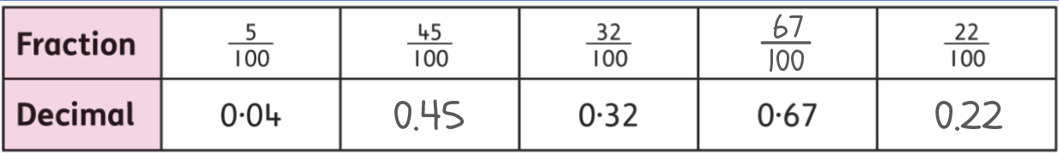

Part C, p. 142:
Anticipated Student Responses
- 1 square = 0.01
- 5 squares = 0.05 or 1/20
- 0.19 = 19 squares
- 0.1 = 10 squares

Part D, p. 142B:
Anticipated Student Responses
- 0.25 = 1/4
- 0.5 = 1/2
- 0.75 = 3/4

Part A, p. 143:
Anticipated Student Responses
- 1.13 | - 4.30 | - 3.06 | - 0.55

Part B, p. 143:
Anticipated Student Responses
Student answers for the part-whole models will vary. Look out for decimals with hundredths written as fractions over 100 (or less), and decimals with only tenths being written as fractions over 10 (or less).

Part C, p. 143:
Anticipated Student Responses
- B | - A | - B

Part A, p. 143:
Anticipated Student Responses
4.1 = 4, 4.6 = 5, 5.7 = 6, 12.7 = 13, 12.4 = 12, 27.8 = 28 (all rounded to the nearest whole number)

