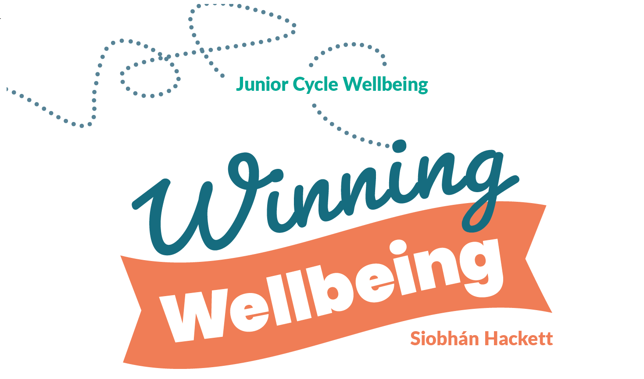

TEACHER’S
GUIDE



Introduction
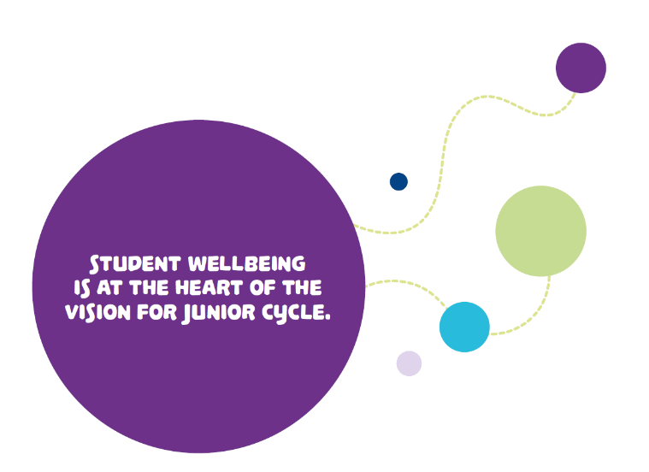
There has been a strong focus on mental health and wellbeing in public discussion over the past two decades, and the level of attention given to wellbeing in schools reflects this concern. What is undeniably true is that the evidence suggests that rates of depression, self-harm and anxiety among young people are at unprecedented levels.
Here in Ireland, a very significant development in the new Junior Cycle is the development of the Wellbeing programme. There is a recognition that learning for life for all of us must include learning about how to manage ourselves in our personal and social lives, and the new curriculum emphasises this aspect of learning in the Wellbeing component.
The Department of Education and Skills, in reviewing its policy and approach to promoting
the wellbeing of all children and young people in
schools and centres for education, is setting out to
ensure that by 2023:
- The promotion of wellbeing will be at the core of the ethos of every school and centre
for education.
- All schools and centres for education will provide evidence-informed approaches and support, appropriate to need, to enhance the wellbeing of all.
- Ireland will be recognised as a leader in wellbeing promotion in schools and centres for education.
As teachers, we all want our students to be confident, resilient and positive, and we need to help to facilitate them in being taught how. We can help parents to support their children’s wellbeing by creating an environment in which our students can flourish. By teaching positive behaviour development to our students, we can instil a way of life that they can carry forward into adulthood.
There are many situations in life we cannot control. What we can control is how we react to those situations. This book tries to teach that lesson. It is full of proven strategies and practical activities that are based on experience and research. I really hope you enjoy it and that it makes a real difference in your life and the lives of your students.
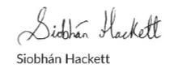
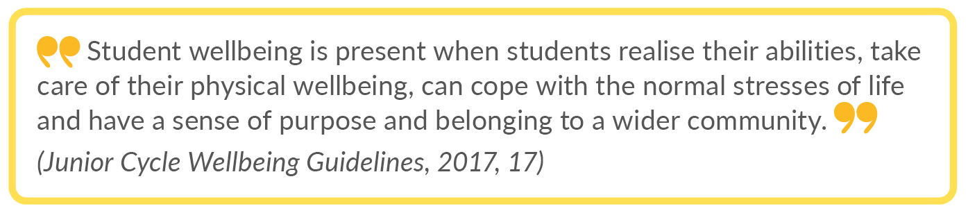

The Junior Cycle Wellbeing programme
The Junior Cycle Wellbeing programme is 400 hours of time-tabled learning for First Year students from September 2022. Instilling life skills and wellbeing skills in school supports our young people. It is important to teach research-based life skills such as happiness skills, strength skills, resolution skills, emotional skills, skills for being present, interaction skills, relationship skills, self-management skills, as well as empathy skills at school.
This publication Winning Wellbeing builds on substantial work already taking place in schools in support of students’ wellbeing and includes learning opportunities to enhance the physical, mental, emotional and social wellbeing of all students. It also enables students to build life skills and develop a strong sense of connectedness.
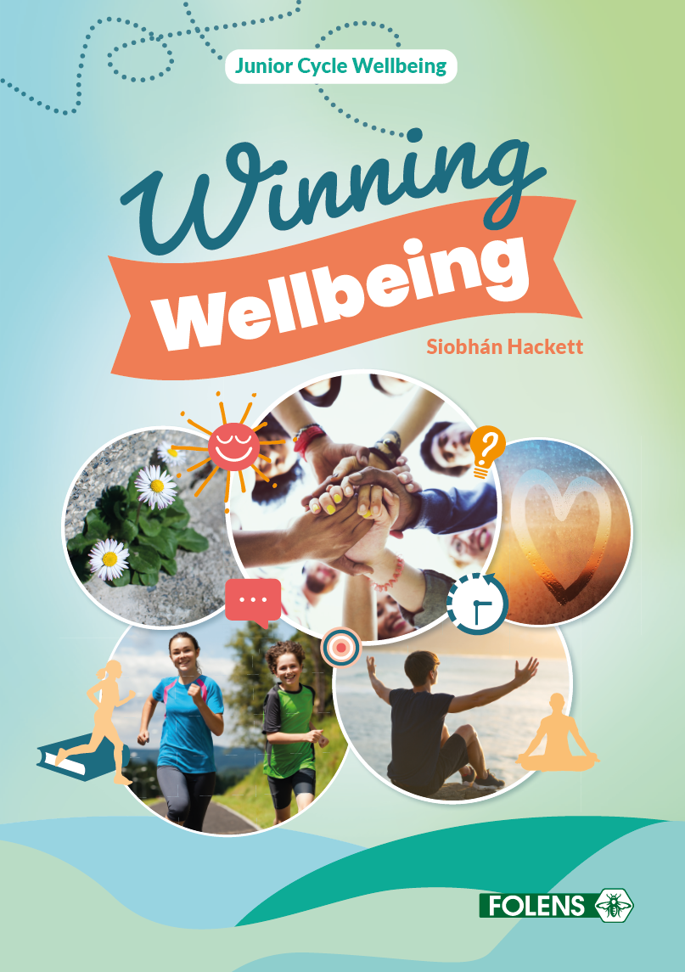

Providing our students with strong foundations that promote student wellbeing and positive relationships in our fast-paced world empowers them, helping them to reach their full potential and achieve their aspirations in life and in learning. Maintaining wellbeing is a prerequisite for learning, and if our students basic social and emotional needs are not being met, education cannot lead to success.

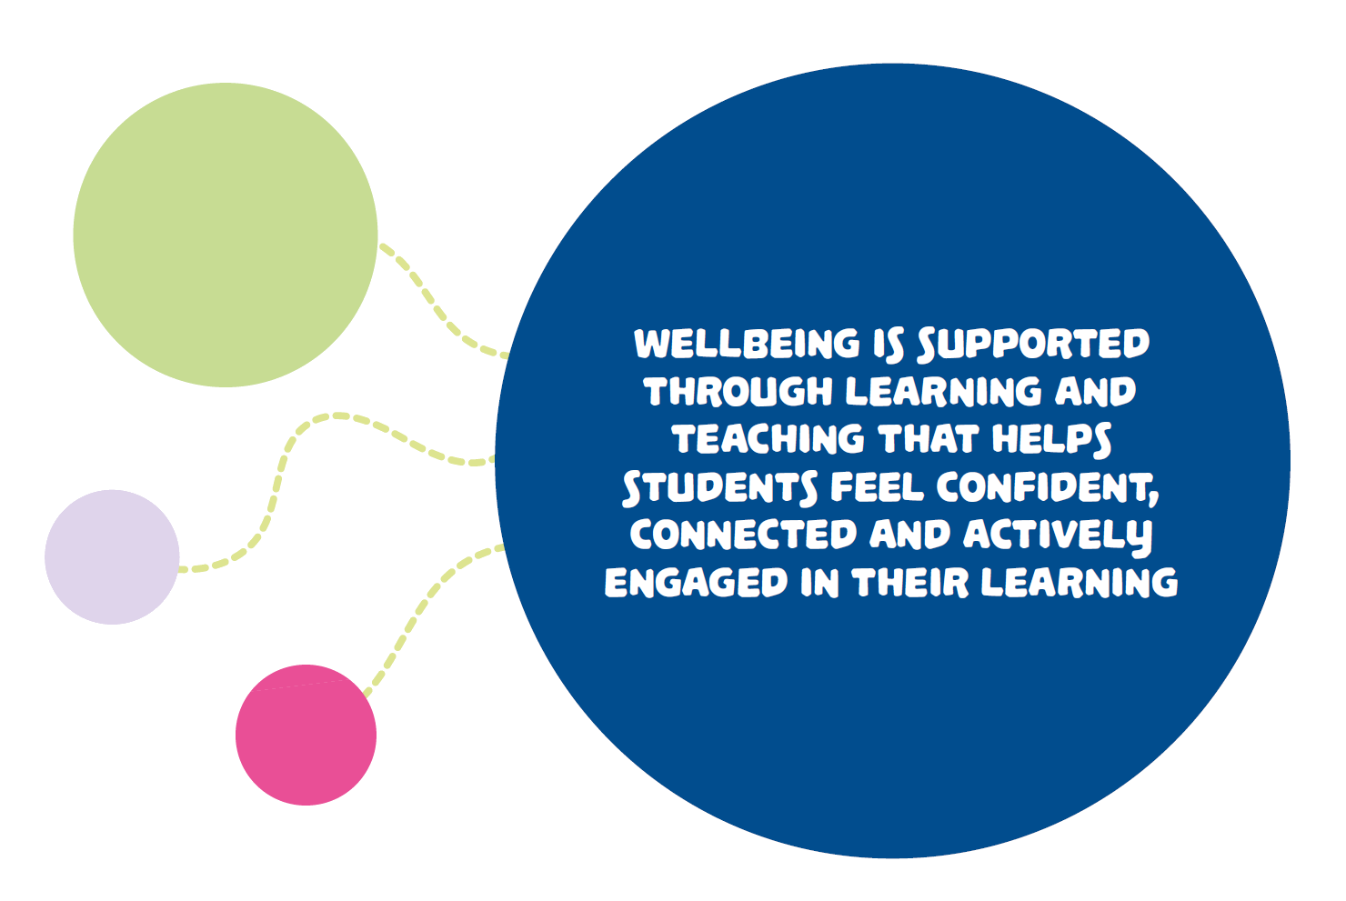

Wellbeing in Junior Cycle is about all young people feeling confident, happy, healthy and connected. Winning Wellbeing provides learning opportunities that will help to develop these attributes in a fun and experiential way. Using storytelling, games and activities to instil this knowledge allows topics to be taught in an easy and straightforward way, while at the same time helping students to remain engaged so they can participate more fully. As a result, the lessons will stay with them so much longer, and we all know improved well-being is synergistic with improved learning. As the Chinese proverb states: ‘Tell me, I’ll forget; Show me, I’ll remember; Involve me, I’ll understand.’
Winning Wellbeing is designed to inspire and educate our students to learn strategies to take charge of their own mental health and maintain their own emotional, social and physical wellbeing. It places an emphasis on the experiential learning of a variety of techniques – so our students get to experience mindfulness, cognitive behavioural therapy techniques, reframing, gratitude, etc., and find what works for them. In essence, they are equipped with essential life skills.
The reality is that many teachers are conscripted into teaching Wellbeing subjects and don’t always feel comfortable or qualified teaching it. We believe this publication can help teachers by covering these sometimes serious but important topics in an easy and clear manner and in a fun and practical way. By focusing on these topics in a different way that is not intense, with activities and games, everyone can have some fun while still learning. This book aims to alleviate additional stress for teachers by having a ‘one-stop shop’ resource-free lesson approach for the busy teacher. All lessons have individual, pair and class group activities. Our hope is that Winning Wellbeing will empower teachers to feel comfortable and competent enough to teach wellbeing, which in turn will lead to us really empowering our students.

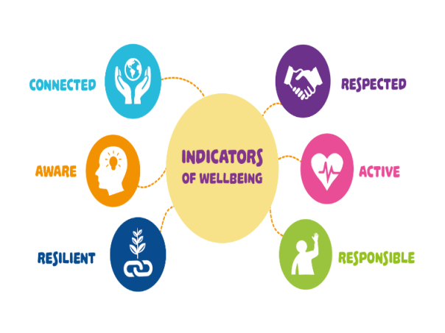
Our students’ wellbeing is of central importance to their educational success and overall happiness, and student wellbeing is at the heart of the vision of the new Junior Cycle programme. Central to wellbeing are the six basic indicators: Active, Responsible, Connected, Resilient, Respected and Aware. These indicators make explicit what is important for young people in supporting their wellbeing and in their learning. The Wellbeing indicators play a central role in all wellbeing-related subjects and form the basis on which our Junior Cycle curriculum is built.

According to research, employers are not just looking for academic success but key employability skills, such as the ability to self-manage, solve problems and work well as part of a team.
In a constantly changing environment, having life skills is an essential part of being able to meet
the challenges of everyday life. To cope with the increasing pace and change of modern life, students need new life skills such as the ability to deal with stress and frustration. These wellbeing indicators help them to be aware of their wellbeing so that they can build on their
life and wellbeing skills.
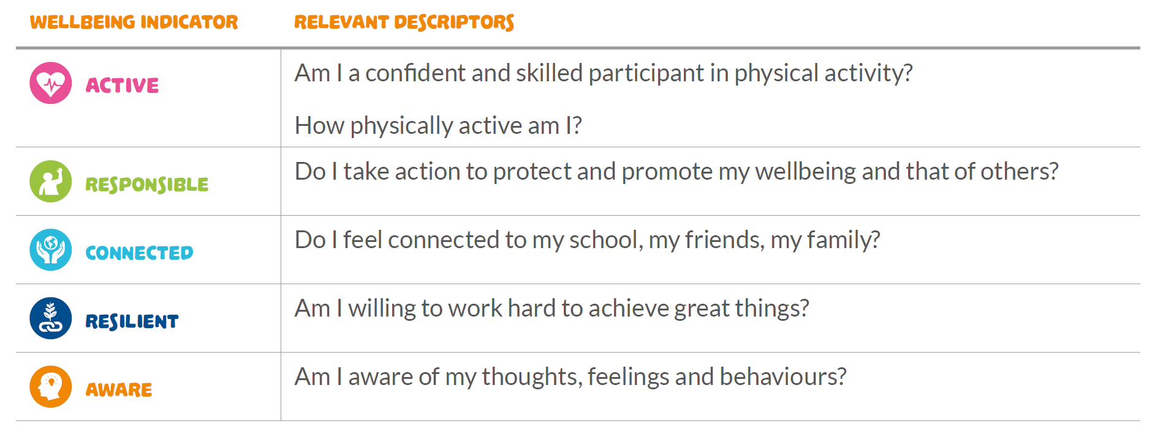

Winning Wellbeing is centred around the six basic indicators mentioned above and through various activities, pair work and group work, students will develop a positive sense of themselves and their social, emotional and physical well-being. The contents page shows the lessons that are addressed under the various indicators:
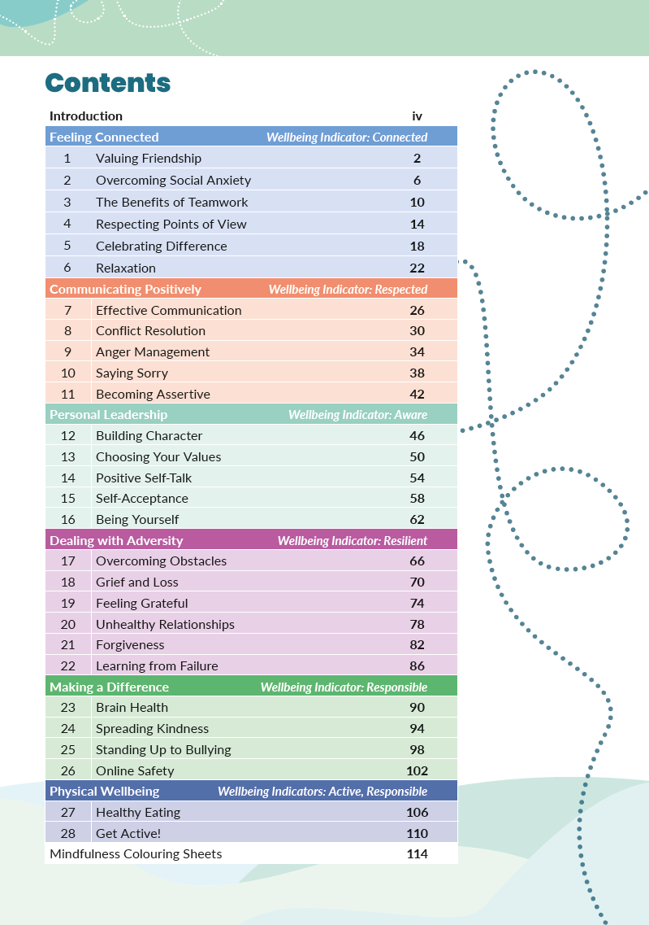

Navigating the book layout
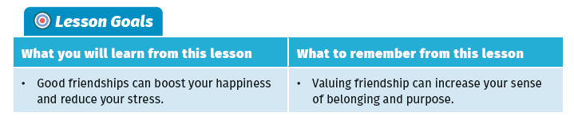
Goals: Each lesson begins with lesson goals.

The lesson goals define the ‘why’ behind the lesson so that everyone understands the reasons for learning a given topic, and outline what our students will ideally be able to accomplish once the lesson is completed.

Activities: Every lesson includes a range of class activities.
Student collaboration is integral to learning. Class activities help students build their social, emotional and interpersonal skills. Group work and pair work are two of the most common types of student collaboration. The use of pair work and group work as a teaching and learning methodology is of great benefit to students. Through participation in group work, our students learn from and with one another. It is also a great chance to practise collaboration and communication skills. Student collaboration is also very beneficial to shyer students, who may initially be reluctant to contribute in front of the whole class group. You do not have to cover all activities. There is simply a choice of activities on what you think is most suitable for your students on a given day.
At times, group work can be a complex process, but enabling students to work through that complexity is part of what we want our students to experience. Some useful strategies for structuring and assigning group work to our students and promoting positive collaboration
include the following:
- Choose your groups methodically if the activity allows it.
- Set ground rules for group interaction.
- Encourage students to ask questions.
- Ensure everyone listens to others within the group, and encourage all group members to participate.
- Before starting the activity, make sure to discuss the group’s activity in order to reach a shared understanding.
- To ensure everyone’s shared understanding, it can be helpful to summarise the activity on the whiteboard.
- Where possible with activities, give students some freedom of choice.
- To keep everyone on task, ensure that each group member is accountable and responsible for their task with an agreed timeline.
- It can be helpful to appoint a group leader and another member to write down and record the group’s feedback.
- Check in with groups for understanding, for redirecting and for reminding them to stay on task.
Features: Within each lesson there are a range of features.
Shine a Light sections profile famous people and how they overcame personal challenges or set examples to others.
Short stories are used to help set the scene for topics being covered.
The Big Question feature asks an important question about a topic at the beginning of a lesson.
Did You Know? boxes share fun and interesting facts.
Suggestion boxes offer ideas for further activities or initiatives after completing a lesson or an activity. It is a great way of extending activities that students have learned and perhaps developing them into a greater initiative.

Reflection: At the end of every lesson there is a Time For Reflection section where students can record what they learned. Learning in Wellbeing aims to encourage young people to be mindful of others and to take responsibility for their social, emotional and physical health. However, it is important that students are encouraged to reflect at the end of each lesson on their learning so that they can move beyond just thinking about knowledge learned and instead be prompted to consider how key skills have been developed through the lesson. This could be done for a few minutes at the end of each lesson or for homework.
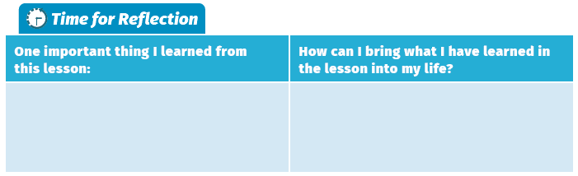
A strong sense of wellbeing helps us to feel good about ourselves and the way our lives are going and can have a hugely positive impact on teenage mental health. High levels of wellbeing in teenagers can help them flourish in life, as well as act as a protective factor against some of the challenges that may arise during the teenage years.

As a teacher, how will Winning Wellbeing help me?
Winning Wellbeing is an Irish production designed for teachers by an Irish teacher who is aware of the day-to-day challenges of the classroom. It builds the foundational knowledge and skills essential for looking after wellbeing.

- Simple structure: A straightforward, consistent four-page structure in each lesson makes it easy to follow.

- Achievable and flexible: The book is structured with the school calendar in mind. There are 28 short lessons – achievable within a class and within the school year. It allows flexibility for schools when it comes to timetabling the extra hours and will also work for the schools who have smaller modules already in place.

- Engaging: A strong emphasis on experiential learning and reflection will help students to develop wellbeing skills that they can take with them into later school and adult life.

- Variety and choice: Every lesson offers a range of activities, so you can select the activities that are best suited to your class. The book is designed with First Year in mind but may also be used in Second or Third Year.

- Teacher support: The lessons have been carefully written to support teachers of all experience levels to cover sometimes serious, always important topics.

- Alignment to the wellbeing indicators: The book is aligned to the six indicators of wellbeing: Active, Aware, Connected, Resilient, Respected, Responsible.

- Teacher as facilitator: Clear instructions throughout the lesson ensure the teacher’s main role is as a facilitator – offering support and advice when needed and providing the necessary scaffolding of skills when necessary.

- Fun, resource-free activities: Supports teachers in developing resilient learners with positive character strengths and coping skills in a fun way without having to gather resources as you run from one class to the next.

- Online resources: The following resources are all available on FolensHIVE: audio recordings, PowerPoints, helpful worksheets and a list of inspirational YouTube videos related to lessons in Winning Wellbeing.

- Evidence-based: Winning Wellbeing uses educational psychology, cognitive behavioural therapy, positive psychology, mindfulness, self-esteem elevation activities and neuroscience.

- Time-saving workbook style: Saves teachers having to photocopy and plan additional activities to deepen the understanding of learners.

How will Winning Wellbeing help my students?
It is important for young people to build on their wellbeing life skills so that they can understand the interaction between thoughts, feelings and behaviour, and develop coping strategies that will better enable them to manage the everyday pressures of teenage life. This books helps students to improve their wellbeing by making small, evidence-based and easy changes to their lifestyles.

- Age-appropriate: Students will find age-appropriate material, information, advice and fun experiential activities that help them to understand issues and topics that are important to their wellbeing at school and in life.

- Student-centred: Students are guided through the lesson where they will complete activities designed to allow them to be more aware and knowledgeable about their own emotional health and wellbeing.

- Builds confidence: Building inner confidence and fostering positive thinking helps students to understand what mental health and wellbeing are and ways to support them.

- Builds life skills: Assists in developing resilience, emotional regulation, managing anger and conflict, positive character strengths, values and coping skills.

- Supports academic learning: Wellbeing is a prerequisite for learning.

- Encourages ‘bouncebackability’: By learning to believe in their capacity to overcome hardship, students build a sense of mastery over their life circumstances.

- Conflict resolution and anger management: By building on anger management skills and conflict resolution skills, teenagers are better able to navigate the sometimes stormy waters of adolescence.

- Building on helpful thinking styles: By recognising unhelpful thinking styles and behaviours, students learn how they could change them to make small, practical improvements.

- Literacy development: Students will build knowledge by mastering new vocabulary and sharing ideas with others.

- Easy to comprehend: The lessons make complex topics fun, relevant, enjoyable and engaging.

- Covers key topics: Including healthy minds and bodies, respecting diversity, building positive relationships, being safe online, protecting against bullying, the importance of gratitude, etc.

- Real-life situations: Many of the activities in this book mimic real-life situations, which develops our students’ ability to handle common day-to-day stresses and problems.

